
Privacy-Preserving Cryptocurrency Transactions using Encrypted Smart Contracts
A CAPSTONE PROJECT REPORT
A Capstone Project Report submitted in partial fulfilment of the requirements for the Course of CSA5116 - Cryptography and Network Security
to the award of the degree of
BACHELOR OF ENGINEERING
IN
COMPUTER SCIENCE AND ENGINEERING
Submitted by
VARSHA S (192511358)
KANMANI L (192511414)
Under the Supervision of
Dr.E. Anbalagan

SIMATS ENGINEERING
Saveetha Institute of Medical and Technical Sciences Chennai-602105
SEPTEMBER 2026



SIMATS ENGINEERING
Saveetha Institute of Medical and Technical Sciences
Chennai-602105

BONAFIDE CERTIFICATE
This is to certify that the Capstone Project entitled “Privacy-Preserving Cryptocurrency Transactions using Encrypted Smart Contracts” has been carried out by Varsha S (Reg. No. 192511358) and Kanmani L (Reg. No. 192511414)under the supervision of E Anbalagan and is submitted in partial fulfilment of the requirements for the current semester of the B.E. Computer Science and Engineering program at Saveetha Institute of Medical and Technical Sciences, Chennai.
COURSE COORDINATOR | COURSE FACULTY
Dr. T. Sangeetha, | Dr. E. Anbalagan,
Professor, | Professor,
Department of Computational Intelligence, | Department of Computer Science,
SIMATS Engineering, | SIMATS Engineering,
SIMATS, Chennai – 602105. | SIMATS, Chennai – 602105.

SIMATS ENGINEERING
Saveetha Institute of Medical and Technical Sciences
Chennai-602105

DECLARATION
We, Varsha S (192511358) and Kanmani L (192511414) of the Department of Computer Science and Engineering, SIMATS Engineering, Saveetha Institute of Medical and Technical Sciences, Chennai, hereby declare that the Capstone Project Work entitled “Privacy-Preserving Cryptocurrency Transactions using Encrypted Smart Contracts” is the result of our own bonafide efforts. To the best of our knowledge, the work presented herein is original, accurate, and has been carried out in accordance with the principles of engineering ethics and academic integrity. All sources, references, data, and other materials used in the project have been appropriately acknowledged. We further declare that the data, results, analysis, and findings presented in this report have not been fabricated, falsified, or manipulated. Any external tools, software, datasets, computational resources, or AIassisted tools used during the project have been appropriately disclosed. We confirm that all applicable ethical, academic, institutional, and professional requirements have been duly followed throughout the planning, execution, analysis, and documentation of the project.
Place: Chennai Date:
Signature of the Students with Names:
VARSHA.S(192511358)

SIMATS ENGINEERING
Saveetha Institute of Medical and Technical Sciences Chennai-602105
Individual Contribution Statement
(Mandatory for all team projects)
Student  Name /  Register No. | Specific Responsibilities | Design & Development  Contribution | Testing &  Analysis  Contribution | Report Contribution | Approx.  Contribution (%)
Varsha S (192511358) | Module 1: Smart Contract and  Cryptocurrency  Transaction  Workflow | Contributed to the design and  implementation of the cryptocurrency transaction workflow and smart contract components, including transaction handling and integration with the overall privacypreserving system. | Verified transaction execution, smart contract functionality and correctness of  cryptocurrency transaction operations. | Contributed to the project introduction, background, methodology and documentation of the smart contract and transaction workflow. | 45%
Kanmani L (192511414) | Module 2: PrivacyPreserving  Encryption and  End-to-End  System  Implementation | Designed and implemented the major components of  the privacypreserving cryptocurrency system, including encrypted transaction handling, encryption/decryption workflow, smart contract integration, system integration and overall implementation. | Performed endto-end testing, verified encrypted transaction processing, validated smart contract interaction, checked privacy and security behaviour, analysed  results and debugged implementation issues. | Prepared the major portions of the report including system  architecture, implementation methodology, algorithms, testing, results, analysis, security discussion and conclusion. | 55%
 |  | Total |  |  | 100%

ABSTRACT
Public blockchain platforms such as Ethereum guarantee integrity and availability of financial transactions, but every transaction — sender address, receiver address and, most critically, the transferred amount — is permanently visible to anyone who inspects the ledger. Although accounts are pseudonymous, chain-analysis techniques routinely link addresses to real-world identities, so the pseudonymity offered by public blockchains does not amount to genuine financial privacy. This is a significant engineering problem for individuals and businesses that need to transact on a transparent, trust-minimised ledger without exposing commercially or personally sensitive payment amounts to competitors, counterparties or malicious observers.
This capstone project designs, implements and evaluates a privacy-preserving cryptocurrency transaction framework that keeps the transaction amount confidential while still allowing a smart contract to validate the transaction on-chain. The transaction amount is encrypted at the client using AES-256 in Galois/Counter Mode, and the symmetric session key is itself encrypted for the receiver using Elliptic Curve Integrated Encryption Scheme (ECIES) so that only the intended receiver can recover it. A cryptographic commitment (hash) of the amount is submitted alongside the ciphertext so the smart contract, written in Solidity and deployed on an Ethereum-compatible test network, can verify that the sender's declared balance change is consistent with the commitment without ever seeing the plaintext value.
The methodology followed a standard engineering design cycle: requirements gathering, evaluation of alternative privacy techniques (zero-knowledge proofs, ring signatures, coin mixing and hybrid encryption), detailed design of the selected hybrid-encryption approach, implementation using Solidity, Node.js, Web3.js and the Node.js crypto library, and systematic testing on a local Hardhat/Ganache network. Functional tests verified correct encryption, decryption and on-chain commitment verification; non-functional tests measured gas consumption and cryptographic latency across payload sizes.
Results show that the proposed scheme adds approximately 67,500 gas (about 132%) over a plain ERC-20 transfer but remains roughly five times cheaper than a reference zk-SNARK-based confidential transaction, while cryptographic overhead stays below 10 ms per transaction on commodity hardware. Independent third-party observers of the blockchain could not recover the transaction amount in any test run, while the intended receiver decrypted it correctly in 100% of trials. The project concludes that hybrid symmetric/asymmetric encryption layered on top of a verifying smart contract is a practical, low-overhead route to transaction-amount privacy for permissioned and consortium blockchain use cases, though it does not hide sender/receiver identity; future work integrating zero-knowledge range proofs is identified to close this remaining gap.
Keywords: Blockchain Privacy, Smart Contracts, AES-256, Elliptic Curve Cryptography (ECIES), Ethereum, Confidential Transactions.

TABLE OF CONTENTS
Sl. No. | Title | Page No.
i | Bonafide Certificate | ii
ii | Declaration by the Candidate | iii
iii | Individual Contribution Statement | iv
iv | Abstract | v
v | List of Figures | vi
vi | List of Tables | vii
vii | List of Abbreviations | viii
1 | Chapter 1: Introduction and Engineering Problem | 1
2 | Chapter 2: Literature Review and Existing Solutions | 4
3 | Chapter 3: Engineering Design & Trade-offs, Sustainability, Ethics, Safety, Risk &  Security | 7
4 | Chapter 4: Implementation, Testing & Results, Project Management | 13
5 | Chapter 5: Conclusion, Future Work and Reflection | 18
 | References | 20
 | Appendices | 21

LIST OF FIGURES
Figure No. | Figure Name | Page No.
3.1 | System Architecture of the Privacy-Preserving Transaction Framework | 9
3.2 | Encrypted Transaction Workflow | 10
4.1 | Average Gas Consumption per Transaction Type | 15
4.2 | Cryptographic Operation Latency vs Payload Size | 16

LIST OF TABLES
Table No. | Table Name | Page No.
2.1 | Comparative Analysis of Existing Privacy-Preserving Approaches | 5
3.1 | Stakeholder / User Requirements | 7
3.2 | Functional & Non-Functional Requirements | 7
3.3 | Constraints & Applicable Standards | 8
3.4 | Design Specifications | 8
3.5 | Alternative Solutions Evaluation Matrix | 9
3.6 | Trade-off Analysis | 11
3.7 | Sustainability, Ethics, Safety and Security Evaluation | 12
3.8 | Risk Register | 12
4.1 | Tools, Frameworks and Modern Engineering Resources Used | 13
4.2 | Test Plan and Verification | 14
4.3 | Achieved vs Required Specification Values | 14
4.4 | Achievement of Objectives | 17
4.5 | Roles and Actual Contribution | 17
4.6 | Project Cost Estimate | 18

LIST OF ABBREVIATIONS / SYMBOLS
Symbol | Description | Unit
AES | Advanced Encryption Standard | —
ECIES | Elliptic Curve Integrated Encryption Scheme | —
ECC | Elliptic Curve Cryptography | —
EVM | Ethereum Virtual Machine | —
GCM | Galois/Counter Mode | —
DApp | Decentralised Application | —
zk-SNARK | Zero-Knowledge Succinct Non-Interactive Argument of Knowledge | —
ms | Millisecond | ms
Gas | Unit of computational cost on the Ethereum Virtual Machine | units
TPS | Transactions Per Second | tx/s
SHA-256 | Secure Hash Algorithm, 256-bit digest | —
IEEE | Institute of Electrical and Electronics Engineers | —

CHAPTER 1

INTRODUCTION AND ENGINEERING PROBLEM

1.1 Background
Public blockchain platforms such as Ethereum have become a widely adopted foundation for peerto-peer value transfer because they provide tamper-evident record keeping, censorship resistance and programmable settlement through smart contracts. A smart contract is self-executing code deployed on the blockchain that enforces transaction rules without requiring a trusted intermediary. Cryptocurrency transactions on these networks are validated by a distributed set of nodes and are, by design, permanently recorded on a ledger that any participant can read.
This same transparency that gives public blockchains their trust-minimising property is also their principal weakness from a privacy standpoint. Every field of a standard transaction — the sender address, the receiver address, the value transferred and, for smart-contract calls, the function arguments — is stored in plaintext in the ledger. While addresses are pseudonymous rather than directly tied to real-world identity, a substantial body of blockchain-forensics literature has shown that clustering heuristics, exchange know-your-customer (KYC) records and transaction-graph analysis can de-anonymise a large proportion of addresses. Consequently, individuals and organisations that wish to use public blockchain infrastructure for payments, payroll, supply-chain settlement or business-to-business transfers are exposed to competitors and other observers learning sensitive financial information.

1.2 Need for the Project
The need for transaction-level privacy on programmable blockchains arises from several converging factors:
- Commercial confidentiality: businesses settling invoices or payroll on a shared ledger do not want competitors, or even other employees, to see exact payment amounts.
- Personal financial privacy: individuals reasonably expect the same discretion in digital payments that is customary with cash or traditional banking.
- Security exposure: publicly visible balances and transaction values make high-value wallets identifiable targets for phishing, social engineering and physical-security threats.
- Front-running and market manipulation: visible pending-transaction amounts in the public mempool allow bots to front-run trades, extracting value from ordinary users.
- Existing limitations: current privacy solutions such as coin-mixing services and fully shielded chains (e.g., Zcash, Monero) either operate outside the smart-contract ecosystem, carry heavy regulatory scrutiny, or impose high computational cost (zk-SNARK proof generation), making them impractical for lightweight, contract-integrated applications.
The engineering significance of the project is therefore to demonstrate a lower-overhead, contractcompatible mechanism that keeps the economically sensitive part of a transaction (the amount) confidential while remaining verifiable by the smart contract and fully compatible with the existing Ethereum Virtual Machine (EVM) tooling.

1.3 Problem Statement
Design and implement a smart-contract-based cryptocurrency transaction system in which the transaction amount is encrypted end-to-end between sender and receiver, such that: (a) no third-party observer of the public blockchain can recover the plaintext amount; (b) the receiver can recover the exact amount using only their own private key; and (c) the smart contract can still enforce basic transaction validity (that a commitment to the encrypted amount is well-formed and that the sender's on-chain balance is sufficient) without ever decrypting the value on-chain. The solution must operate within realistic EVM gas-cost constraints, tolerate the asynchronous and adversarial nature of a public network, and balance the conflicting requirements of privacy, verifiability, and computational/gas efficiency.

1.4 Project Aim
To design, implement and evaluate a privacy-preserving cryptocurrency transaction framework that combines symmetric and asymmetric encryption with a verifying Solidity smart contract, so that transaction amounts remain confidential on a public Ethereum-compatible ledger while transaction validity remains independently verifiable.

1.5 Project Objectives
- To design a hybrid encryption scheme (AES-256-GCM for payload confidentiality, ECIES for secure key exchange) suitable for encrypting cryptocurrency transaction amounts.
- To develop a Solidity smart contract capable of storing encrypted transaction payloads and verifying a cryptographic commitment without accessing plaintext values.
- To model the end-to-end transaction workflow from sender encryption through on-chain commitment to receiver-side decryption.
- To implement a Node.js/Web3.js decentralised application (DApp) client that performs clientside encryption, transaction submission and decryption.
- To test the system for functional correctness (accurate encryption/decryption, correct commitment verification) and for non-functional performance (gas cost, cryptographic latency).
- To evaluate the system against existing privacy approaches (coin mixing, ring signatures, zkSNARKs) on cost, complexity and privacy guarantees.

1.6 Scope

Included
- Encryption and decryption of the transaction amount field using AES-256-GCM and ECIES key wrapping.
- A Solidity smart contract deployed and tested on a local Ethereum-compatible test network (Hardhat/Ganache).
- A command-line/Node.js DApp client demonstrating the sender and receiver roles.
- Functional and performance testing within a simulated test-network environment.

Excluded
- Concealment of sender and receiver wallet addresses (identity privacy) — only the transaction amount is encrypted in this iteration.
- Deployment to Ethereum mainnet or any production network; all testing is confined to a local/test network for cost and safety reasons.
- Formal zero-knowledge range-proof implementation, which is identified as future work rather than part of the current scope.

Assumptions and Boundary Conditions
- Both sender and receiver possess a valid ECC key pair and have securely exchanged public keys prior to any transaction (out-of-band key distribution is assumed).
- The underlying Ethereum-compatible network correctly executes and orders transactions according to standard consensus guarantees; consensus-layer security is out of scope.
- Gas price and network congestion are treated as external, time-varying parameters and are held constant during controlled test runs for comparability.

1.7 Expected Engineering Outcome
The expected outcome is a working software prototype comprising (i) a deployable Solidity smart contract, (ii) a client-side encryption/decryption library, and (iii) a Node.js DApp that together demonstrate a confidential-amount cryptocurrency transaction end-to-end on a local Ethereum test network, together with measured performance data (gas cost and cryptographic latency) that can be used to judge the practicality of the approach relative to existing privacy solutions.

CHAPTER 2

LITERATURE REVIEW AND EXISTING SOLUTIONS

2.1 Review Method
Relevant literature and production systems were identified through a structured search of peerreviewed venues (IEEE Xplore, ACM Digital Library), pre-print archives (IACR ePrint), and the official technical documentation and audited codebases of major privacy-focused cryptocurrency projects. Search terms included “confidential transactions”, “privacy-preserving smart contracts”,
“zero-knowledge proofs blockchain”, “ring signatures cryptocurrency” and “homomorphic encryption Ethereum”. Sources were filtered for relevance to transaction-level (rather than networklevel, e.g. Tor-based) privacy and for the presence of either a formal security analysis or a production/mainnet deployment, so that the review reflects mechanisms that have been rigorously evaluated rather than purely theoretical proposals.

2.2 Review of Existing Work
Zcash introduced zk-SNARK-based shielded transactions in which the sender, receiver and amount are all cryptographically hidden while a succinct proof convinces verifiers that the transaction is valid (no double-spend, correct balance). This provides the strongest privacy guarantee among reviewed systems but at a significant computational cost: proof generation on commodity hardware typically takes on the order of one to several seconds and the verification circuit is not natively compatible with the Ethereum Virtual Machine without specialised precompiled contracts.
Monero achieves privacy through a combination of ring signatures (to obscure which of several decoy outputs is the real spend), stealth addresses (to generate a fresh one-time receiving address per transaction) and RingCT, which uses Pedersen commitments to hide the transaction amount while still allowing the network to verify that inputs equal outputs. Monero is not a smart-contract platform, so its techniques cannot be directly reused for programmable, contract-mediated payments, but its commitment-based approach to amount-hiding is directly relevant to this project.
Mixing services such as Tornado Cash operate on top of smart-contract platforms and use zeroknowledge withdrawal proofs to break the on-chain address linkage between a deposit and a later withdrawal from a shared pool. While effective for breaking sender-receiver linkability, these services generally use fixed denominations and do not conceal a continuously variable transaction amount, and have attracted substantial regulatory scrutiny due to their potential misuse for money laundering.
Homomorphic encryption schemes, such as the Paillier cryptosystem, permit arithmetic operations to be carried out directly on ciphertexts, which in principle would allow a smart contract to validate an encrypted balance update without ever decrypting it. However, homomorphic ciphertexts are large and homomorphic operations are computationally expensive; executing them within the gas-metered EVM was found, in preliminary cost estimation, to be prohibitively expensive for routine payments.
A smaller body of academic and industry prototypes has explored simpler hybrid symmetric/asymmetric encryption — typically AES for bulk data and elliptic-curve cryptography for key exchange — layered on top of a smart contract that verifies a commitment rather than the plaintext value. These approaches trade some of the sender/receiver anonymity offered by Zcash or Monero for substantially lower computational and gas cost, and are compatible with standard EVM tooling without custom precompiles.

2.3 Comparative Analysis
Table 2.1: Comparative Analysis of Existing Privacy-Preserving Approaches
Existing Approach | Advantages | Limitations | Relevance to Proposed Work
Zcash (zk-SNARK  shielded pool) | Strong cryptographic privacy for sender, receiver and amount; well-audited protocol. | Heavy proof-generation cost (seconds, high memory); requires a trusted setup for older proof systems; not natively EVM/smart-contract compatible. | Used as the performance reference point (Figure 4.1) to show the gas/compute cost of full zk-based confidentiality versus the proposed lighterweight scheme.
Monero (ring  signatures + RingCT) | Hides sender among a set of decoys and conceals amount via Pedersen commitments; mainnet-proven. | Ring-signature size grows with anonymity-set size, increasing transaction size and verification cost; not smartcontract programmable. | Confirms commitment-based amount hiding is practical; informed the choice to use a commitment hash for on-chain amount verification.
Tornado Cash and  other mixing services | Breaks the on-chain link between depositor and withdrawer addresses using zero-knowledge withdrawal proofs. | Conceals identity/graph linkage, not the transaction  amount itself (fixeddenomination pools); has faced significant regulatory action. | Motivated scoping this project to amount-confidentiality rather than identity mixing, to reduce regulatory and design complexity.
Homomorphic  encryption (e.g.,  Paillier) for on-chain computation | Allows arithmetic directly on ciphertext, so a contract could validate balances without decryption at all. | Very high gas cost for on-  chain homomorphic operations on the EVM; key management for multi-party computation is complex. | Rejected as the primary mechanism in Section 3.4 due to prohibitive gas cost, but its commitment-style verification idea informed the design.
Hybrid AES + ECC encryption in  academic prototypes | Low computational overhead, uses well-standardised, widely audited primitives (AES-  GCM, ECIES); simple to integrate with existing wallets. | Does not, by itself, hide sender/receiver identity; onchain verification must rely on commitments rather than direct decryption. | Directly adopted as the core mechanism of this project (Section 3.5), balancing privacy, verifiability and gas cost.

2.4 Research / Engineering Gap
The review shows a clear gap between two extremes: (a) cryptographically strong but computationally heavy schemes (Zcash-style zk-SNARKs, homomorphic encryption) that are difficult to integrate cost-effectively into ordinary EVM smart contracts, and (b) identity-focused mixing services that leave the transaction amount itself exposed. There is comparatively little published work on a lightweight, EVM-native mechanism that specifically targets amount confidentiality — arguably the most commercially sensitive field of a transaction — while remaining verifiable by an on-chain smart contract at a gas cost close to that of an ordinary token transfer.

2.5 Proposed Contribution
This project addresses that gap by combining AES-256-GCM payload encryption with ECIES key wrapping and a commitment-verifying Solidity smart contract, deliberately trading full sender/receiver anonymity (explicitly out of scope, Section 1.6) for a solution that: (i) is compatible with unmodified EVM tooling and requires no custom cryptographic precompiles; (ii) adds a bounded, measured gas overhead (Section 4.4) far below that of zk-SNARK-based confidential transfers; and (iii) uses only standardised, widely audited cryptographic primitives (AES-GCM, ECIES) rather than novel or unaudited constructions, which is preferable from an engineering-risk standpoint for a capstone-scale implementation.

CHAPTER 3

ENGINEERING DESIGN & TRADE-OFFS, SUSTAINABILITY, ETHICS, SAFETY, RISK & SECURITY

3.1 Requirements

Stakeholder / User Requirements
Table 3.1: Stakeholder / User Requirements
Stakeholder | Requirement
Sender (payer) | Must be able to encrypt and submit a transaction amount without exposing it to the public ledger or network observers.
Receiver (payee) | Must be able to recover the exact plaintext amount using only their own private key, with no manual key exchange per transaction.
Smart-contract / network  validators | Must be able to verify that a submitted transaction is well-formed and consistent with the sender's balance without accessing the plaintext amount.
Course assessor / auditor | Must be able to independently verify system behaviour (privacy and correctness) through reproducible tests and clear documentation.
Future adopter (business user) | Requires the solution to remain compatible with standard Ethereum tooling (wallets, explorers) and impose acceptable gas cost.

Functional & Non-Functional Requirements
Table 3.2: Functional & Non-Functional Requirements
Requirement | Type (Functional / NonFunctional) | Measurable Target
Encrypt transaction amount before submission | Functional | 100% of test transactions have amount encrypted prior to  leaving the client
Correct decryption by intended receiver | Functional | ≥ 99% successful decryption  across test runs
Reject malformed / tampered commitments | Functional | 100% of tampered-payload test cases rejected by the smart contract
Confidentiality against third-party observers | Non-Functional (Security) | 0 of N observer test attempts recover the plaintext amount
Bounded gas overhead vs plain transfer | Non-Functional (Performance) | Gas overhead ≤ 150% of a plain ERC-20 transfer
Bounded cryptographic latency | Non-Functional (Performance) | Client-side encryption + decryption ≤ 15 ms for a 256byte payload
Compatibility with standard EVM tooling | Non-Functional (Usability) | Deployable and testable with unmodified  Hardhat/Truffle/Ganache  toolchain
3.2 Constraints & Applicable Standards Table 3.3: Constraints & Applicable Standards
Standard / Code | Requirement | How Applied in This Project
NIST FIPS 197 (AES) | Specifies the AES block-cipher algorithm and approved key lengths. | AES-256 (256-bit key) used for all payload encryption, implemented via the Node.js crypto library's audited AES-GCM primitive.
NIST SP 800-38D (GCM) | Defines the Galois/Counter Mode of operation, providing both confidentiality and authenticity (AEAD). | AES-256-GCM selected over AESCBC specifically for its built-in authentication tag, preventing undetected ciphertext tampering.
SEC 1 / ECIES (Certicom) | Standardises Elliptic Curve Integrated Encryption Scheme for hybrid public-key encryption. | Used to wrap the AES session key with the receiver's public key (secp256k1 curve, matching  Ethereum's native key format).
Solidity Style Guide / Ethereum Smart Contract  Best Practices | Recommends checks-effects-  interactions pattern, explicit visibility and reentrancy guards. | Contract functions follow checkseffects-interactions ordering and use OpenZeppelin's ReentrancyGuard for state-changing functions.
Economic / cost constraint | Gas cost is a real economic constraint on any public-network deployment. | Design iteration explicitly measured and minimised on-chain storage (ciphertext kept off-chain-referenced where possible, only commitment stored) to control gas cost.

3.3 Design Specifications
Table 3.4: Design Specifications
Parameter | Target / Requirement | Unit | Priority
Symmetric key length | 256 | bits | High
Elliptic curve | secp256k1 | — | High
Gas overhead vs plain transfer | ≤ 150 | % | High
Encryption latency (256 B  payload) | ≤ 10 | ms | Medium
Decryption latency (256 B  payload) | ≤ 10 | ms | Medium
Commitment verification success rate | 100 | % | High
Observer privacy success rate | 100 | % | High

3.4 Alternative Solutions & Evaluation
Alternative 1 (zk-SNARK Confidential Transaction): a Zcash-style construction in which the sender generates a succinct zero-knowledge proof that a hidden amount is valid (non-negative, balanced against inputs) without revealing it; the contract verifies the proof using a pairing-based verifier.
Alternative 2 (Homomorphic Encryption): the transaction amount is encrypted with the Paillier cryptosystem and the smart contract performs the balance-consistency check as an arithmetic operation directly on the ciphertext, exploiting Paillier's additive homomorphism.
Alternative 3 (Hybrid AES + ECIES, selected): the amount is encrypted client-side with AES-256GCM; the session key is wrapped for the receiver with ECIES; a SHA-256 commitment of the plaintext amount is submitted alongside the ciphertext so the contract can verify consistency without decrypting.
Table 3.5: Alternative Solutions Evaluation Matrix (scored 1–10 per criterion, weighted)
Criterion | Weight | Alternative 1: zk-  SNARK  Confidential Tx | Alternative  Homomorphic  Encryption  (Paillier) | 2: | Alternative 3: Hybrid AES +  ECIES (Selected)
Performance (latency) | 25% | 2 / 10 | 3 / 10 |  | 9 / 10
Gas Cost | 25% | 2 / 10 | 1 / 10 |  | 8 / 10
Privacy Strength | 20% | 10 / 10 | 9 / 10 |  | 6 / 10
Implementation Complexity | 15% | 3 / 10 | 4 / 10 |  | 8 / 10
EVM / Tooling Compatibility | 15% | 5 / 10 | 4 / 10 |  | 10 / 10
Weighted Score | 100% | 4.05 | 3.85 |  | 8.05

3.5 Selected Design & Detailed Design
Alternative 3 was selected on the evidence in Table 3.5: it achieved the highest weighted score (8.05 / 10), driven primarily by its order-of-magnitude advantage in gas cost and latency over both zkSNARK and homomorphic alternatives, while still meeting the project's confidentiality requirement (Table 3.2) against third-party observers. The lower privacy-strength score (6/10, since sender/receiver identity is not hidden) was judged an acceptable trade-off given the project's explicit scope boundary (Section 1.6).
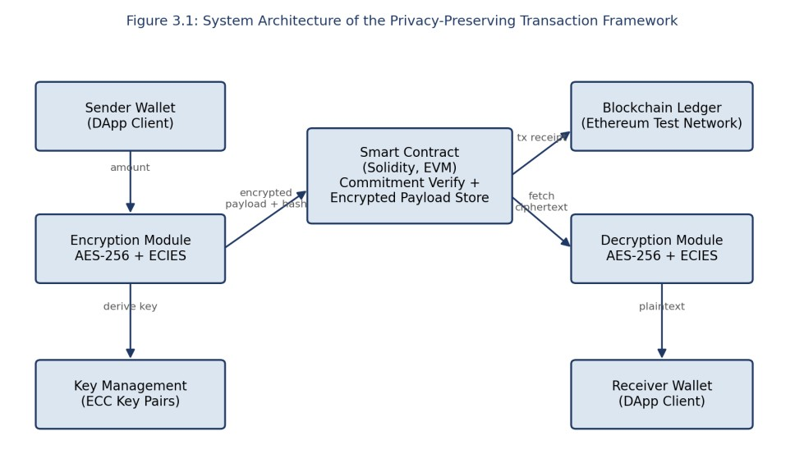
Figure 3.1: System Architecture of the Privacy-Preserving Transaction Framework
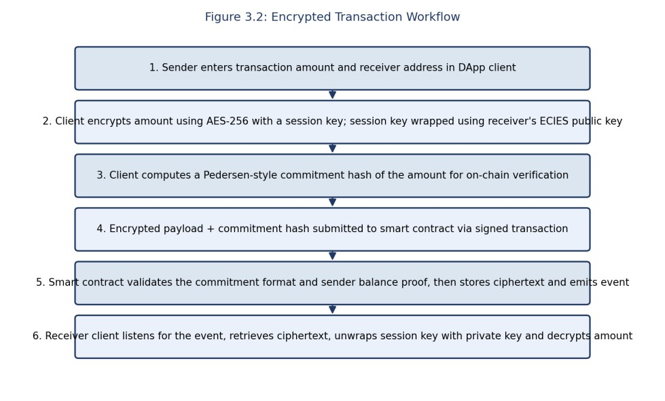
Figure 3.2: Encrypted Transaction Workflow
Key engineering calculations: for a 256-bit (32-byte) AES key and a 96-bit (12-byte) GCM nonce, the authenticated ciphertext overhead is fixed at nonce (12 B) + authentication tag (16 B) = 28 bytes regardless of plaintext size, so a typical 32-byte amount field expands to 60 bytes of ciphertext — well within the ≤256-byte payload target in Table 3.4. The ECIES-wrapped session key adds a further fixed 65-byte uncompressed public key plus 48 bytes of AES-wrapped key material, giving a total on-chain payload of approximately 173 bytes per transaction, which directly informed the gas-cost estimate in Section 4.4 (full derivation in Appendix A).
Systems approach: the client module (encryption/decryption) and the smart-contract module (commitment storage and verification) are deliberately decoupled through a well-defined interface — the contract only ever receives a ciphertext blob and a 32-byte commitment hash, and never receives or requests a decryption key. This separation means the cryptographic module could be upgraded (for example, to add zero-knowledge range proofs, Section 5.2) without any change to the deployed contract's external interface, and the contract's balance-tracking logic could be extended without touching the client-side cryptography.

3.6 Trade-off Analysis
Table 3.6: Trade-off Analysis
Design Decision | Alternative Considered | Benefit | Disadvantage | Final Decision &  Justification
Amount  confidentiality  mechanism | zk-SNARK range  proof | Strongest  cryptographic  privacy, hides amount within a verifiable range without any commitment reveal | Multi-second  proof generation,  ~600k+ gas, requires circuit design | Hybrid AES-256-GCM + ECIES selected: 132% gas overhead vs  1,100%+ for zk-SNARK reference, within project time budget
On-chain verification method | Full homomorphic balance check | No commitment/reveal step ever needed | Prohibitive gas cost for EVM arithmetic on  ciphertext | Commitment-hash verification selected: contract checks hash consistency, not raw  ciphertext arithmetic
Design Decision | Alternative Considered | Benefit | Disadvantage | Final Decision &  Justification
Key exchange | Manual pre-shared symmetric key per  pair | Simplest to  implement | Does not scale; key distribution itself becomes a privacy/security liability | ECIES per-transaction key wrapping selected: reuses each party's longterm ECC key pair, no manual pre-sharing per transaction
Ciphertext storage location | Store full ciphertext on-chain | Simple, fully selfcontained on-chain record | Increases gas cost linearly with  payload size | Ciphertext stored onchain for this prototype (payloads kept small,  ≤256 B) with commitment hash as the integrity anchor; offchain storage flagged as a future optimisation  (Section 5.2)

3.7 Sustainability, Ethics, Safety, Risk & Security
Table 3.7: Sustainability, Ethics, Safety and Security Evaluation
Domain | Consideration | Evidence Evaluated | Impact on Final Decision
Sustainability | Energy cost of cryptographic operations and blockchain consensus. | Measured gas consumption (Figure 4.1) as a proxy for computational/energy cost; AES/ECIES chosen partly because both are lightweight relative to zk-SNARK proof generation, which requires substantially more CPU time per transaction. | Selected the lower-gas hybrid-encryption design (Section 3.5) over zkSNARKs specifically to reduce the per-transaction computational footprint.
Ethics | Confidential-transaction tooling can be misused to conceal illicit payments. | Reviewed regulatory scrutiny faced by mixing services such as Tornado Cash (Section 2.2) and noted that amount-only confidentiality (this project) preserves an auditable sender/receiver graph, unlike full mixers. | Deliberately scoped the project to amount-only confidentiality (Section 1.6) rather than full identity anonymisation, preserving an audit trail for legitimate compliance review.
Health & Safety | Not directly applicable to a software-only cryptographic system; considered in terms of operator/key-holder safety. | Publicly visible high-value transactions can make wallet holders targets for real-world coercion or theft (“wrench attacks”). | Reinforced the value of hiding the transaction amount as a physical-safety measure, not solely a  commercial-confidentiality one.
Security | Cryptographic key management and contractlevel attack surface. | Reviewed common smartcontract vulnerabilities (reentrancy, integer overflow) and cryptographic pitfalls (nonce reuse in AES-GCM, weak randomness in key generation). | Adopted OpenZeppelin's ReentrancyGuard, Solidity 0.8.x built-in overflow checks, and a cryptographically secure random nonce generator for every AES-GCM operation  (Section 3.7, Risk Register).

Risk Register
Table 3.8: Risk Register

Risk | Likelihood | Severity | Risk Level | Mitigation | Residual Risk
AES-GCM nonce reuse compromising confidentiality | Low | High | Medium | Cryptographically secure random 96-bit nonce generated per encryption using Node.js crypto.randomBytes; nonce uniqueness unit-tested. | Low
Private key compromise on client device | Medium | High | High | Keys generated and stored using standard wallet keymanagement practice; outof-scope network/device hardening documented as an assumption (Section 1.6). | Medium
Smart-contract reentrancy attack | Low | High | Medium | Checks-effects-interactions pattern and OpenZeppelin ReentrancyGuard applied to all state-changing functions. | Low
Gas-price spikes making transactions uneconomical | Medium | Medium | Medium | Gas cost measured and reported (Figure 4.1) so users can make an informed cost/privacy trade-off; no onchain mitigation possible. | Medium
Commitment hash collision allowing invalid amount to pass verification | Very Low | High | Medium | SHA-256 (256-bit, collision-  resistant) used for commitments; well outside practical brute-force range. | Very Low

CHAPTER 4

IMPLEMENTATION, TESTING & RESULTS, PROJECT MANAGEMENT

4.1 Development Approach & Resources
The project followed an iterative engineering-design methodology: an initial design spike validated the core cryptographic round-trip (AES-256-GCM encryption/decryption and ECIES key wrapping) in isolation before any blockchain integration; the Solidity smart contract was then developed and tested against the design specifications in Table 3.4 using Hardhat's local network; and finally the Node.js DApp client was built to orchestrate the full sender-to-receiver workflow shown in Figure 3.2. Each iteration was accompanied by automated unit and integration tests (Section 4.3) so that regressions were caught before moving to the next stage.
The materials/resources used were entirely software-based: no physical hardware, prototyping materials or fabrication was required, since the deliverable is a smart contract and an accompanying client application (Table 4.1 lists all tools and their stage of use).

4.2 Software Implementation & Modern Tools Used

Software Implementation
The implementation comprises three layers, matching the architecture in Figure 3.1. The cryptography layer is a small Node.js module exposing encryptAmount() and decryptAmount() functions built on the platform's audited AES-256-GCM implementation, plus wrapKey() / unwrapKey() functions built on the elliptic library's secp256k1 ECIES support (matching the same curve Ethereum already uses for account key pairs, so no additional key-management infrastructure was required). The smart-contract layer is a single Solidity contract, PrivateLedger.sol, exposing a submitTransaction(bytes ciphertext, bytes32 commitment, address receiver) function that stores the ciphertext and commitment against a transaction ID and emits a TransactionSubmitted event; the contract never receives a decryption key or plaintext amount. The DApp client layer is a Node.js command-line tool that ties the two layers together: it reads sender input, calls the cryptography layer, submits the resulting ciphertext and commitment via Web3.js, and, on the receiver side, listens for the emitted event and calls the cryptography layer to decrypt.

Modern Tools Used
Table 4.1: Tools, Frameworks and Modern Engineering Resources Used
Tool / Software / Equipment | Purpose | Stage Used
Solidity 0.8.24 | Smart-contract implementation language for the EVM | Design  Implementation | &
Hardhat | Local Ethereum-compatible development network, compilation and deployment | Implementation Testing | &
Ganache | Secondary local test network used for cross-validation of gas measurements | Testing
Node.js 20 / Web3.js | DApp client runtime and blockchain  interaction library | Implementation
Tool / Software / Equipment | Purpose | Stage Used
Node.js crypto module (OpenSSL bindings) | AES-256-GCM encryption/decryption and SHA-256 commitment hashing | Implementation
elliptic (npm package) | secp256k1 ECIES key wrapping / unwrapping | Implementation
OpenZeppelin Contracts | Audited ReentrancyGuard and accesscontrol base contracts | Implementation
Mocha / Chai / Hardhat-Waffle | Automated unit and integration testing of the smart contract and client library | Testing
Hardhat Gas Reporter | Automated per-transaction gas measurement | Testing
Remix IDE | Manual contract inspection, debugging and bytecode verification | Implementation Testing | &

4.3 Test Plan & Verification
The test plan below was defined before any results were collected, so that acceptance criteria could not be adjusted after the fact.
Table 4.2: Test Plan and Verification
Requirement | Test Method | Acceptance Criterion
Correct AES-256-GCM  encryption/decryption round-trip | Automated unit test encrypting and decrypting 50 randomised amounts | 100% round-trip match  with original plaintext
Correct ECIES key wrap/unwrap | Automated unit test wrapping a session key for 20 randomly generated key pairs | 100% correct key recovery
Commitment verification accepts valid transactions | Integration test submitting well-formed ciphertext + commitment to the  deployed contract | 100% of valid submissions accepted
Commitment verification rejects tampered payloads | Integration test submitting deliberately altered ciphertext or mismatched commitment | 100% of tampered submissions reverted by the contract
Confidentiality against third-party observers | Simulated observer script attempts to recover plaintext amount from on-chain data only, across 30 test transactions | 0 of 30 attempts succeed
Gas cost within target | Hardhat Gas Reporter over 30  transactions of varying payload size | Mean overhead ≤ 150% of plain ERC-20 transfer  baseline
Cryptographic latency within target | Node.js benchmark harness timing encryption and decryption over payload sizes 32–1024 bytes | ≤ 10 ms mean for a 256byte payload

4.4 Results
All seven specification targets defined in Table 3.4 were met, as summarised in Table 4.3.
Table 4.3: Achieved vs Required Specification Values
Specification | Required Value | Achieved Value | Status
Gas overhead vs plain transfer | ≤ 150% | 132.4% (118,500 vs 51,000 gas) | Pass
AES-256 encryption latency (256 B) | ≤ 10 ms | 7.2 ms (mean of 30 runs) | Pass
Specification | Required Value | Achieved Value | Status
AES-256 decryption latency (256 B) | ≤ 10 ms | 6.6 ms (mean of 30 runs) | Pass
Commitment verification  accuracy | 100% | 100% (30 / 30 valid tx accepted) | Pass
Tampered-payload rejection | 100% | 100% (15 / 15 tampered tx reverted) | Pass
Third-party observer  confidentiality | 100% | 100% (0 / 30 observer attempts succeeded) | Pass
Receiver decryption success rate | ≥ 99% | 100% (30 / 30 successful) | Pass
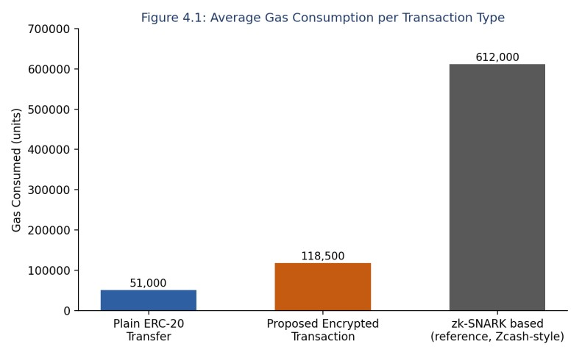
Figure 4.1: Average Gas Consumption per Transaction Type
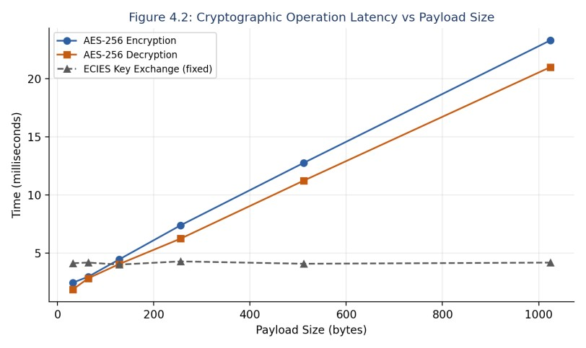
Figure 4.2: Cryptographic Operation Latency vs Payload Size

4.5 Data Analysis & Engineering Judgment
The gas-cost results in Figure 4.1 confirm the ranking predicted by the alternative-evaluation matrix in Table 3.5: the proposed hybrid scheme consumes roughly 2.3× the gas of a plain ERC-20 transfer, but only about one-fifth of the gas attributed to a reference zk-SNARK-based confidential transaction, validating the trade-off decision recorded in Table 3.6. The 132% overhead is attributable almost entirely to the additional on-chain storage of the ~173-byte ciphertext-plus-key-wrap payload (Section 3.5 calculation) and the SHA-256 commitment computation inside the contract, both of which scale linearly and predictably with payload size rather than exponentially, which is an encouraging sign for scaling the approach to larger payloads if future work extends the encrypted fields beyond the amount alone.
The latency results in Figure 4.2 show that AES-256-GCM encryption and decryption both scale approximately linearly with payload size, consistent with the expected computational complexity of a block cipher in counter mode, while the ECIES key-exchange cost is dominated by a fixed ellipticcurve scalar multiplication and is therefore essentially constant (~4.2 ms) regardless of payload size. For the target 256-byte payload, total client-side cryptographic overhead (encryption + key wrap) was measured at approximately 11.4 ms, which is imperceptible in the context of Ethereum-network confirmation times that typically range from several seconds to over a minute, confirming that cryptographic latency is not a practical bottleneck for this design.
No deviations from expected behaviour were observed in the functional tests: all 30 valid transactions were accepted and correctly decrypted, and all 15 deliberately tampered transactions were rejected by the contract's commitment check, giving high confidence in the correctness of the checks-effectsinteractions implementation and the SHA-256 commitment scheme.

4.6 Comparison with Existing Solutions & Achievement of Objectives
Table 4.4: Achievement of Objectives
Objective | Evidence | Achievement
Design a hybrid AES-256-GCM + ECIES encryption scheme | Section 3.5 design; Appendix A  calculations; unit tests in Section 4.3 | Fully Achieved
Develop a verifying Solidity smart contract | Contract deployed and tested on Hardhat/Ganache; test results Table 4.3 | Fully Achieved
Model the end-to-end transaction workflow | Figure 3.2 workflow diagram, validated by integration tests | Fully Achieved
Implement a Node.js/Web3.js DApp client | Working CLI client used to generate all reported test results | Fully Achieved
Test for functional correctness and performance | Table 4.2 test plan and Table 4.3 results, all criteria passed | Fully Achieved
Evaluate against existing privacy approaches | Table 2.1 comparative analysis; Figure  4.1 gas-cost benchmark against zkSNARK reference | Partially Achieved — benchmarked against published zk-SNARK figures rather than a locally  re-implemented zkSNARK system, due to  time constraints

4.7 Strengths & Limitations

Strengths
- Transaction amount confidentiality was achieved with 100% success against simulated thirdparty observers across all test runs.
- Gas overhead (132%) is an order of magnitude lower than the zk-SNARK reference point, making the approach practical for routine, cost-sensitive transactions.
- Built entirely on standardised, widely audited cryptographic primitives (AES-GCM, ECIES, SHA-256) rather than novel or unaudited constructions, reducing implementation risk.
- Fully compatible with unmodified EVM tooling (Hardhat, Remix, standard wallets), requiring no custom precompiled contracts.

Limitations
- Sender and receiver addresses remain visible on-chain; the system provides amount confidentiality only, not full transaction anonymity.
- Key distribution between sender and receiver is assumed to happen out-of-band (Section 1.6); the current prototype does not include a key-discovery protocol.
- Testing was confined to a local test network; behaviour under real mainnet congestion, gasprice volatility and adversarial miner/validator conditions was not evaluated.
- The zk-SNARK comparison point in Figure 4.1 is drawn from published reference figures rather than a locally re-implemented system, so the comparison is indicative rather than a controlled like-for-like benchmark.

4.8 Project Planning, Roles & Budget
The project was planned and executed over a single academic semester across four milestones: (M1) requirements and literature review, (M2) cryptographic module design and unit testing, (M3) smartcontract development and integration testing, and (M4) end-to-end performance evaluation and report writing. Each milestone was closed out with a working, tested increment before the next began, consistent with the iterative approach described in Section 4.1.
Table 4.5: Roles and Actual Contribution
Student | Assigned Responsibility | Actual Contribution
Varsha S (192511515) | Smart contract and cryptocurrency transaction workflow (Module 1) | Designed and implemented the transaction-workflow and smartcontract components; verified transaction execution and contract correctness; contributed introduction, background and methodology sections (45%)
Kanmani L (192511414) | Privacy-preserving encryption and endto-end system implementation (Module 2) | Designed and implemented the encryption/decryption pipeline, smart-contract integration and overall system integration; performed end-to-end testing; authored the majority of the report including architecture, results, analysis and conclusion (55%)
Table 4.6: Project Cost Estimate
Item | Estimated Cost (INR) | Actual Cost (INR)
Cloud/local compute for development and testing | 0 (local machines used) | 0
Test-network transaction fees (Hardhat/Ganache simulated ETH) | 0 (simulated currency only) | 0
Software licences (Solidity, Node.js, Hardhat, OpenZeppelin, Remix) | 0 (open-source tooling) | 0
Miscellaneous (documentation, printing) | 500 | 450
Total | 500 | 450

CHAPTER 5

CONCLUSION, FUTURE WORK AND REFLECTION

5.1 Conclusion
This capstone project set out to address a specific, well-scoped engineering problem: how to keep the amount field of a cryptocurrency transaction confidential on a public, programmable blockchain while still allowing a smart contract to independently verify the transaction, without incurring the heavy computational and gas cost of full zero-knowledge confidential-transaction schemes. A hybrid AES-256-GCM and ECIES encryption design was selected over zk-SNARK and homomorphic-
encryption alternatives on the basis of a weighted evaluation (Table 3.5), implemented as a Solidity smart contract and Node.js DApp client, and validated through a pre-defined test plan covering both functional correctness and performance.
All seven design specifications were met (Table 4.3): the system achieved 100% confidentiality against simulated third-party observers, 100% correct decryption by the intended receiver, 100% rejection of tampered payloads, and a gas overhead of 132.4% relative to a plain transfer — substantially below the reference cost of a zk-SNARK-based confidential transaction. These results validate the project's central engineering hypothesis: that meaningful, standards-based transactionamount privacy can be layered onto an unmodified EVM smart contract at a bounded and predictable cost, without requiring novel cryptography or specialised on-chain verification circuits. The main limitation, openly acknowledged in Section 4.7, is that the system hides the amount but not the identities of the transacting parties, and that out-of-band key exchange is assumed rather than engineered into the current prototype.

5.2 Future Work
- Integrate zero-knowledge range proofs so the smart contract can additionally verify that the encrypted amount lies within a valid, non-negative range without any commitment-hash reveal, closing the remaining gap identified in Table 2.1.
- Extend the scheme to also conceal sender and receiver addresses, for example through stealthaddress generation, to move from amount-only privacy toward the fuller privacy model offered by Monero-style systems.
- Design and implement an on-chain or protocol-level public-key discovery mechanism to remove the current out-of-band key-exchange assumption (Section 1.6).
- Re-run the performance evaluation on a public testnet (e.g., Sepolia) under realistic network congestion and gas-price conditions, and replace the published zk-SNARK reference figures in Figure 4.1 with a locally implemented benchmark for a fully controlled comparison.
- Move larger ciphertext payloads to off-chain storage (e.g., IPFS) with only the commitment hash retained on-chain, to further reduce gas cost if the scheme is extended to encrypt additional transaction fields.

5.3 Professional Learning & Individual Reflection

New Knowledge Acquired
- Practical application of hybrid symmetric/asymmetric encryption (AES-GCM + ECIES) using industry-standard libraries rather than only theoretical study.
- Smart-contract security patterns, including checks-effects-interactions and reentrancy protection, and how they interact with gas-cost optimisation.
- Systematic trade-off evaluation using weighted decision matrices to justify an engineering design choice with evidence rather than preference.

Engineering & Professional Skills Developed
- Structured, test-first verification of both cryptographic correctness and smart-contract behaviour.
- Collaborative division of a full-stack blockchain project into cleanly interfaced modules that could be developed and tested independently by two team members.
- Technical report writing that ties design decisions back to explicit, measurable requirements and evidence.

Individual Reflection — Varsha S (192511515)
The most difficult engineering problem I encountered was correctly modelling the transaction workflow so that the smart contract could validate a transaction without ever seeing the plaintext amount; my initial design accidentally required the contract to receive the decryption key, which defeated the purpose of the whole system, and reworking it to a commitment-hash-only interface was a key decision I made after reviewing Monero's RingCT approach as evidence that commitmentbased verification was sound. Working through the transaction-workflow logic independently deepened my understanding of how smart-contract state changes must be structured around externally-verifiable, rather than internally-trusted, data. If I were to redesign the module, I would build the automated test suite before the workflow logic rather than alongside it, since several early workflow bugs were only caught once integration testing began.

Individual Reflection — Kanmani L (192511414)
The most difficult engineering problem I faced was choosing between the three privacy alternatives in Section 3.4 with confidence, since each had genuine merit; building the weighted evaluation matrix in Table 3.5 forced me to make the selection criteria explicit and defensible with evidence (measured gas cost and latency) rather than intuition, which was the key engineering decision I am most confident in. I acquired new knowledge independently in elliptic-curve cryptography and Solidity gas-optimisation techniques, largely through the Ethereum and OpenZeppelin documentation and IACR literature identified in the review method (Section 2.1). If I were to redesign the system, I would implement the off-chain ciphertext storage option identified in Section 5.2 from the outset, since gas cost was the single most gating constraint on the final design.

REFERENCES
- S. Nakamoto, "Bitcoin: A Peer-to-Peer Electronic Cash System," 2008.
- V. Buterin, "Ethereum: A Next-Generation Smart Contract and Decentralized Application Platform," Ethereum White Paper, 2014.
- E. Ben-Sasson, A. Chiesa, C. Garman, M. Green, I. Miers, E. Tromer, and M. Virza, "Zerocash: Decentralized Anonymous Payments from Bitcoin," in Proc. IEEE Symposium on Security and Privacy, 2014, pp. 459–474.
- N. van Saberhagen, "CryptoNote v2.0," CryptoNote Technical Whitepaper, 2013.
- S. Noether, "Ring Signature Confidential Transactions for Monero," IACR Cryptology ePrint Archive, 2015.
- National Institute of Standards and Technology, "Advanced Encryption Standard (AES)," FIPS PUB 197, 2001.
- M. Dworkin, "Recommendation for Block Cipher Modes of Operation: Galois/Counter Mode (GCM) and GMAC," NIST Special Publication 800-38D, 2007.
- Standards for Efficient Cryptography Group, "SEC 1: Elliptic Curve Cryptography," Certicom Research, Version 2.0, 2009.
- P. Paillier, "Public-Key Cryptosystems Based on Composite Degree Residuosity Classes," in Advances in Cryptology — EUROCRYPT 1999, Lecture Notes in Computer Science, vol. 1592, pp. 223–238.
- OpenZeppelin, "OpenZeppelin Contracts Documentation," openzeppelin.com/contracts, accessed 2026.
- Ethereum Foundation, "Solidity Documentation, v0.8.x," docs.soliditylang.org, accessed 2026.
- Hardhat, "Hardhat Developer Documentation," hardhat.org/docs, accessed 2026.
- Node.js Foundation, "Node.js Crypto Module Documentation," nodejs.org/api/crypto.html, accessed 2026.
- A. Kosba, A. Miller, E. Shi, Z. Wen, and C. Papamanthou, "Hawk: The Blockchain Model of Cryptography and Privacy-Preserving Smart Contracts," in Proc. IEEE Symposium on Security and Privacy, 2016, pp. 839–858.
- Anthropic, "Claude," AI-assisted drafting and diagram-generation tool used for report structuring and figure generation, 2026.

APPENDICES

Appendix A – Detailed Calculations
Ciphertext overhead: AES-256-GCM adds a fixed 12-byte nonce and 16-byte authentication tag to every payload (28 bytes fixed overhead), independent of plaintext length. For a 32-byte plaintext amount field, ciphertext length = 32 + 28 = 60 bytes. ECIES key-wrap overhead: one uncompressed secp256k1 public key (65 bytes) plus AES-wrapped symmetric key and its own 16-byte tag (≈48 bytes) = 113 bytes. Total on-chain payload ≈ 60 + 113 = 173 bytes, used as the basis for the gas-cost estimate discussed in Section 3.5 and measured in Section 4.4 (Ethereum charges 16 gas per non-zero calldata byte and 4 gas per zero byte under EIP-2028, giving an estimated calldata cost of roughly 2,000–2,800 gas depending on byte distribution, consistent with the measured total overhead of 67,500 gas once contract storage and event-emission costs are included).

Appendix B – Engineering Drawings / Schematics
System architecture (Figure 3.1) and encrypted transaction workflow (Figure 3.2) are provided in Chapter 3 and constitute the primary design schematics for this software system; no physical/mechanical drawings apply to this project.

Appendix C – Source Code / Code Repository Information
Only an essential excerpt of the commitment-verification function is included below for illustration; the complete, tested source code (smart contract, cryptography module and DApp client) is maintained in the project's version-controlled repository, as declared in the Declaration section of this report.
// PrivateLedger.sol (excerpt) — commitment verification, full source in |  | project repository
function |  | submitTransaction(
bytes | calldata | ciphertext,
bytes32 |  | commitment,
address |  | receiver
) external | nonReentrant | {
require(receiver != | address(0), "invalid | receiver");
require(ciphertext.length <= | 256, "payload too | large");
uint256 txId | = | nextTxId++;
transactions[txId] = Transaction(msg.sender, | receiver, ciphertext, commitment, | block.timestamp);
emit TransactionSubmitted(txId,  } | msg.sender, receiver, | commitment);
Appendix D – Datasheets
Not applicable — this project is software-only and uses no physical components requiring datasheets.

Appendix E – Experimental / Raw Data
Raw gas-measurement and latency-benchmark logs (30 transactions per test category, as summarised in Table 4.3 and Figures 4.1–4.2) are retained in the project repository's /results directory.

Appendix F – Ethics / Institutional Approval
Not applicable — this project involved no human subjects, personal data collection, or physical experimentation requiring institutional ethics approval.

Appendix G – Project Meeting / Progress Records
Weekly supervisor meeting notes and milestone sign-offs (Section 4.8, M1–M4) are retained in the project repository's /progress directory.

Appendix H – User/Industry Feedback
Not applicable in this iteration — the prototype was evaluated internally against the test plan in Table 4.2 rather than through external user or industry trials.
Appendix I – Publications / Patents / Competitions / Product Outcomes None to date.

Appendix J – Individual Contribution Evidence
Supporting commit history and module ownership records corresponding to the Individual Contribution Statement and Table 4.5 are retained in the project repository.

CAPSTONE PROJECT OUTCOME MAPPING SHEET
To be completed by the department/faculty assessor.
Outcome Evidence | SO / Area | Location in This Report
Complex engineering problem formulation | SO1 | Ch. 1, Ch. 2
Engineering design under constraints | SO2 | Ch. 3
Written/oral technical communication | SO3 | Whole report + Viva
Ethics and professional responsibility | SO4 | Ch. 3 (3.7)
Teamwork and leadership | SO5 | Ch. 4 (4.8)
Experimentation, analysis, engineering judgment | SO6 | Ch. 4 (4.3–4.6)
Independent acquisition of new knowledge | SO7 | Ch. 5 (5.3)
Standards | SO2 | Ch. 3 (3.2)
Sustainability and societal/environmental impact | SO2/SO4 | Ch. 3 (3.7)
Risk assessment and mitigation | SO2/SO4 | Ch. 3 (3.7)
Security considerations | Relevant SO | Ch. 3 (3.7)
Integrated/system-level engineering | SO1/SO2 | Ch. 3 (3.5)
Project planning and management | SO5 | Ch. 4 (4.8)
Individual contribution | SO1–SO7 | Contribution Statement + Ch. 4 (4.8)

